**3.2.2 Number of workshops/seminars conducted on Research Methodology, Intellectual Property Rights (IPR) and entrepreneurship during the year**

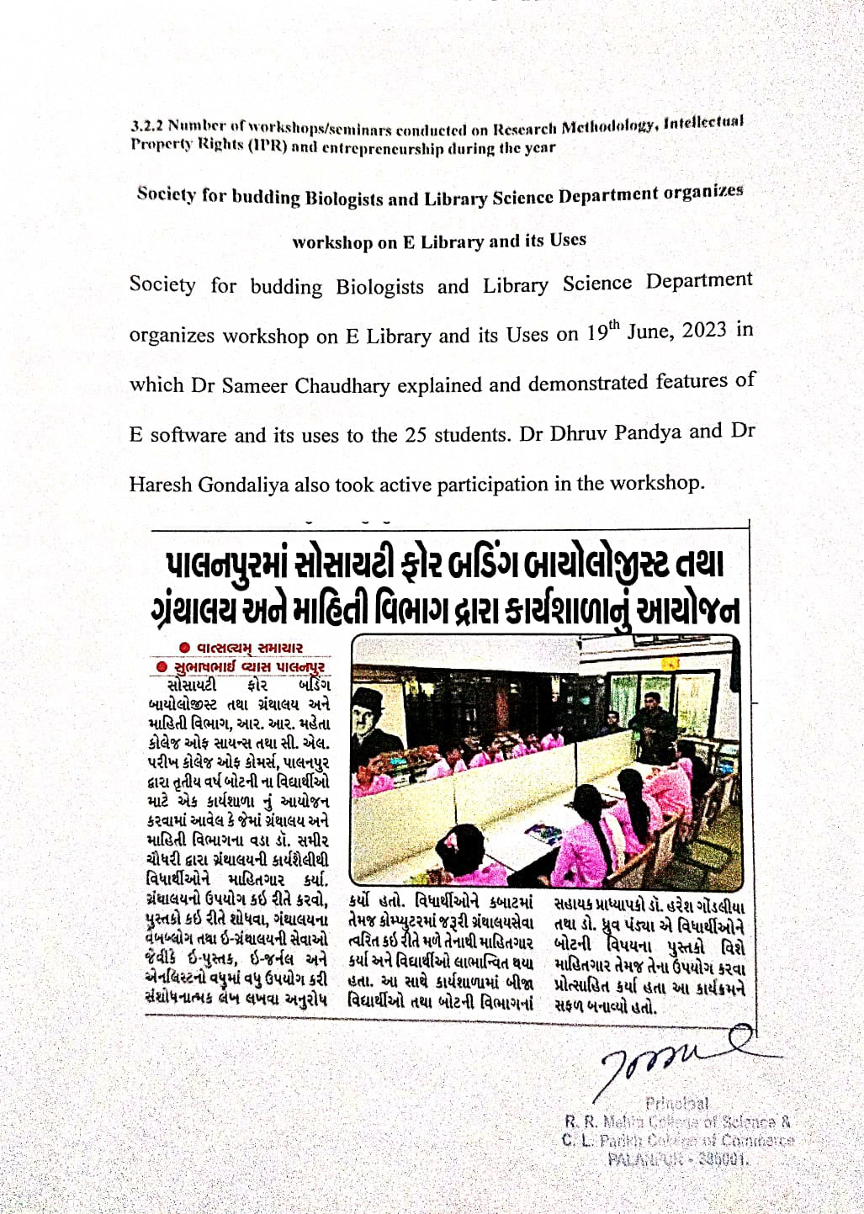 **Workshop on E-Library and its Uses**